# CS 255 System Design Document

COMPANY LOGO

Hi~! it’s me, Ms. DriverPass~!



## UML Diagrams

### UML Use Case Diagram

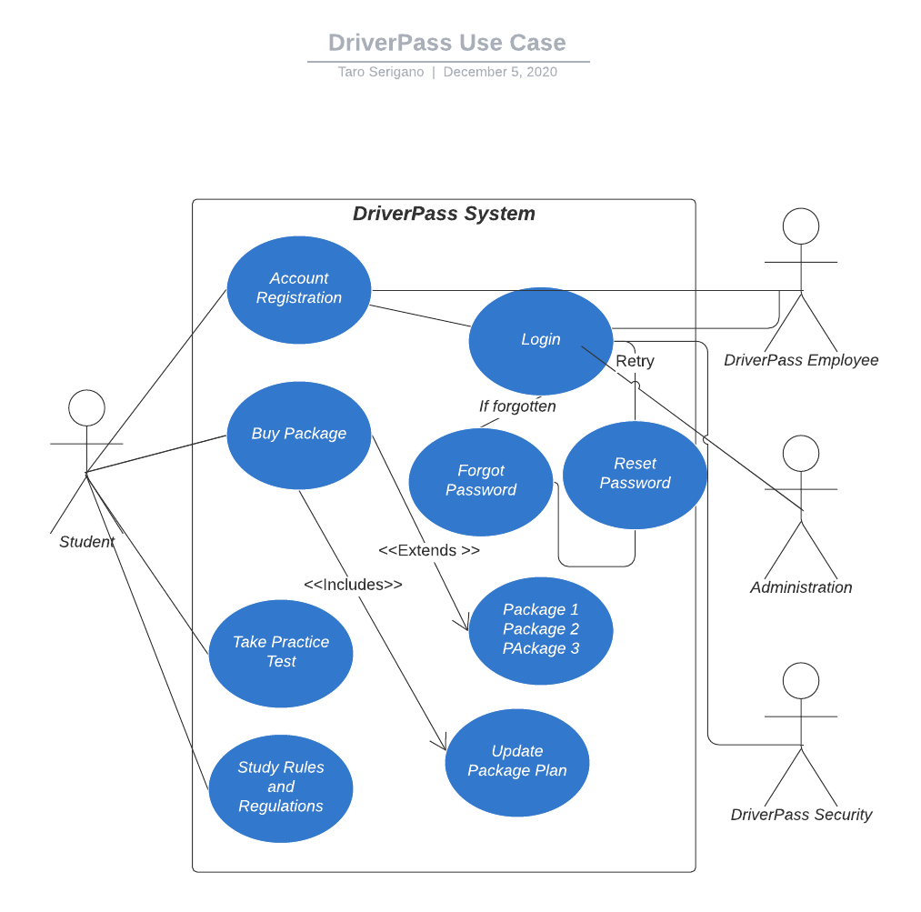

### UML Activity Diagrams

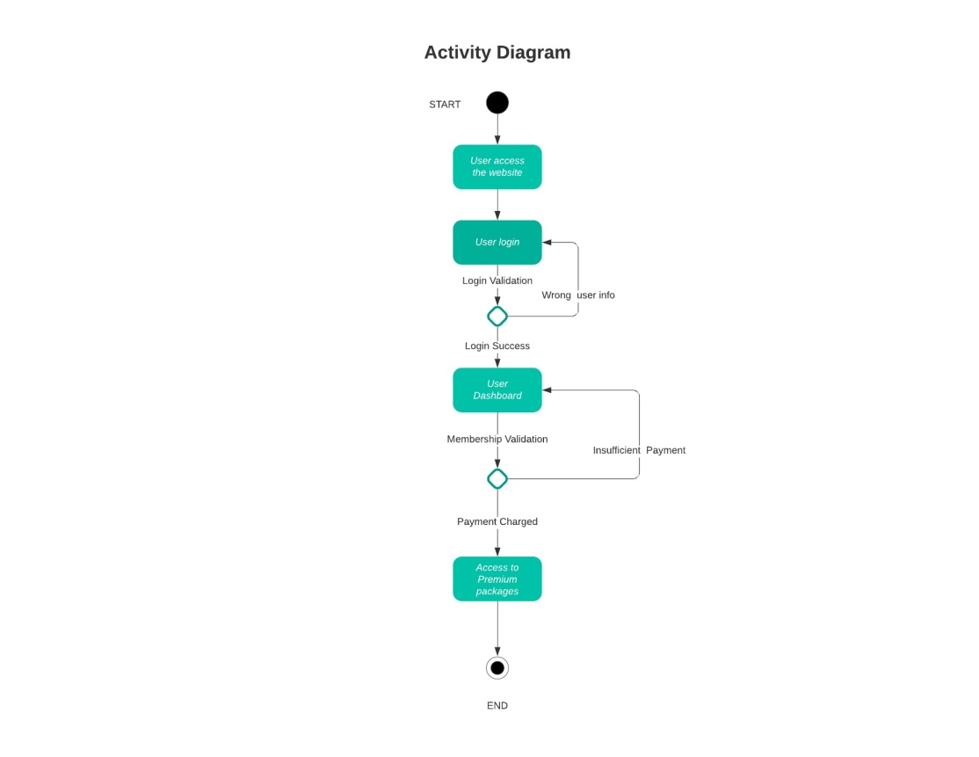

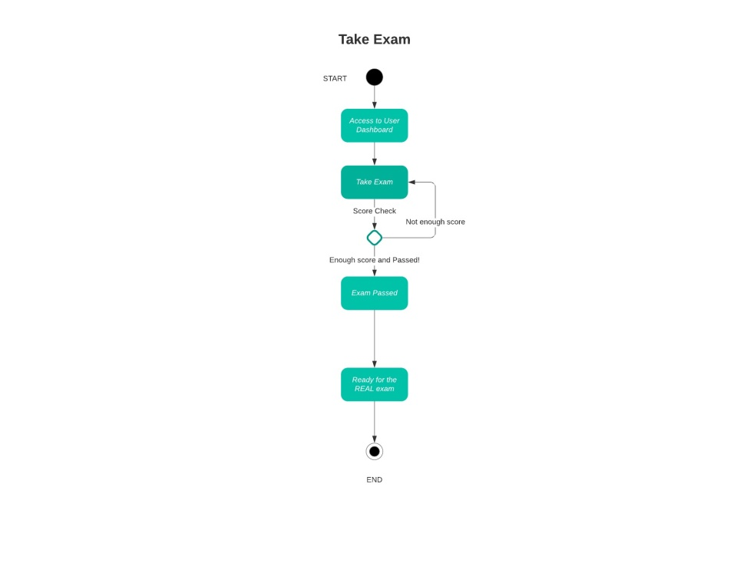

### UML Sequence Diagram

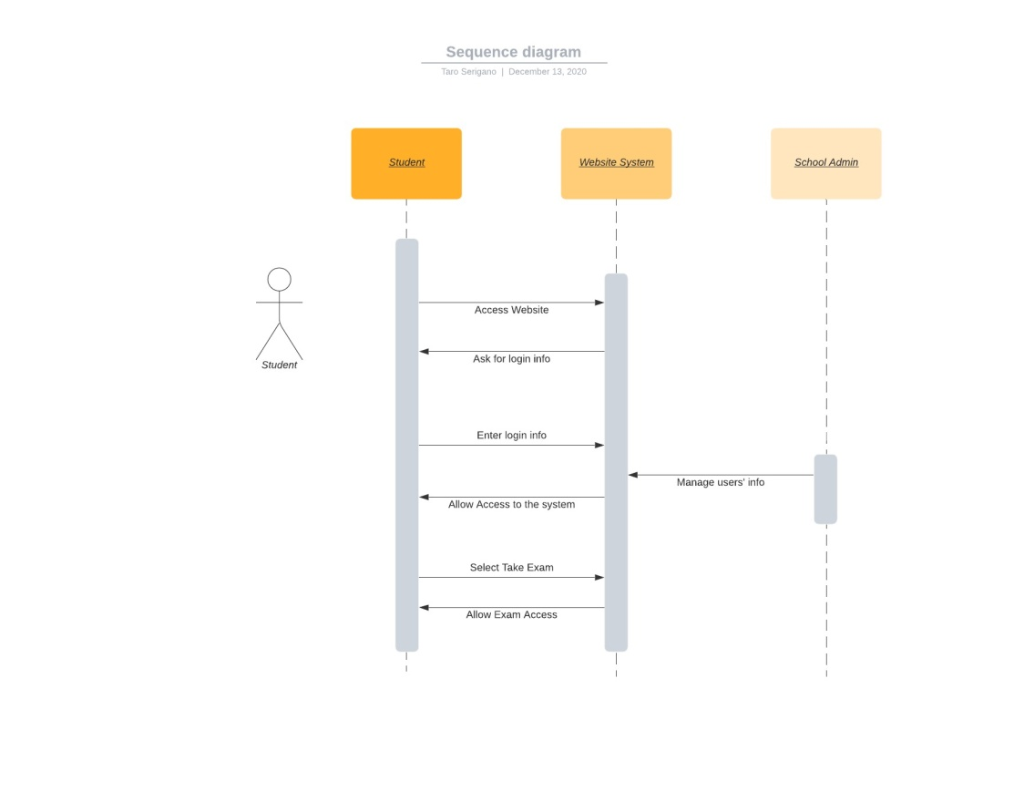

### UML Class Diagram

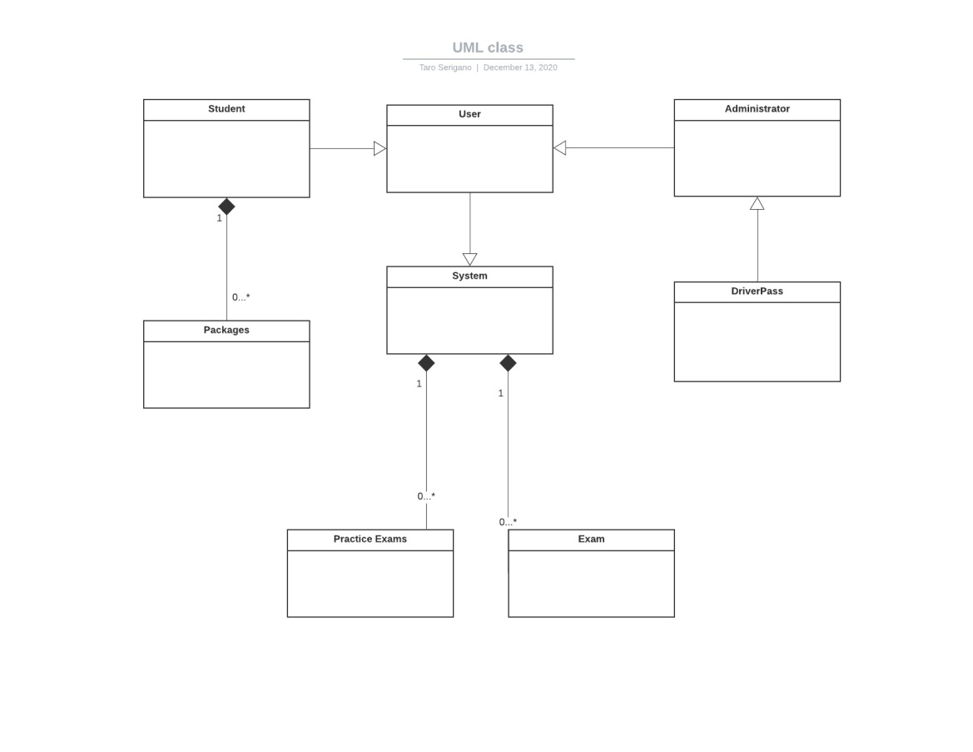

## Technical Requirements

The DriverPass system should install some Linux or Mac based IT system since we’re going to migrate the system with AWS and the compatibility is best with Linux or Mac OS. For the software, tools and infrastructures, all of the services requires can be managed by AWS as IaaS and SaaS model so we won’t have to separate the system and cut costs and time down as result. As for securing the data, we’d have two options to take; 1. Manage and secure the data on-premises entirely 2. We’ll take the hybrid approach and manage and secure the data both on premises and AWS. So the data will be handled by a mixture of cloud, on-premises data center and edge locations. Services like VMware Cloud on AWS can enable you to migrate and extends your on-premises data using the VMware environments. It is highly scalable and lets you migrate your data center services with AWS seamlessly. So we won’t have to be limited with only setting up and running your own server and data centers anymore today. Some companies prefer managing their own data centers entirely on their own, it would be completely up to DriverPass’s preference but we’d highly recommend migrating the system with AWS since it would be much easier, cheaper and can achieve better performance at lower costs and we won’t have to deal hiring extra IT specialists.